Geometry: Unit 13, Lesson 2

- Write the equation in slope-intercept form of a line perpendicular to $y=\frac{1}{4}x-6$ passing through the point $(2, 3)$.

$$y=-4x+11$$

- What is the standard form of the line that has a slope of $4$ and passes through the point $(-3, 7)$?

$$-4x+y=19$$
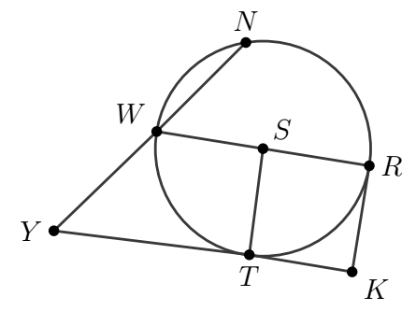
- Circle $S$ is shown, where points $N$, $W$, $T$, and $R$ are on the circle, and points $K$ and $Y$ are outside the circle. Line segments $KR$ and $YK$ are tangent to the circle. What two line segments are perpendicular?

$$\overline{RK}⊥\overline{WR}$$

